WorkDrive Presales Report – May
Here is a 2-sentence executive summary for the presales report: "May 2026 has seen strong presales activity with 97 demos and 72 new prospects, driving a 20.83% conversion rate that resulted in 15 deals won to date. Additionally, we have 19 opportunities currently in progress, indicating continued momentum through the remainder of the quarter."

Conversion Performance
Metric | Value
Total Demos | 97
New Prospect Count | 72
Already Engaged Prospects | 12
Deal Won | 15
In Progress | 19
Conversion Rate | 20.83%

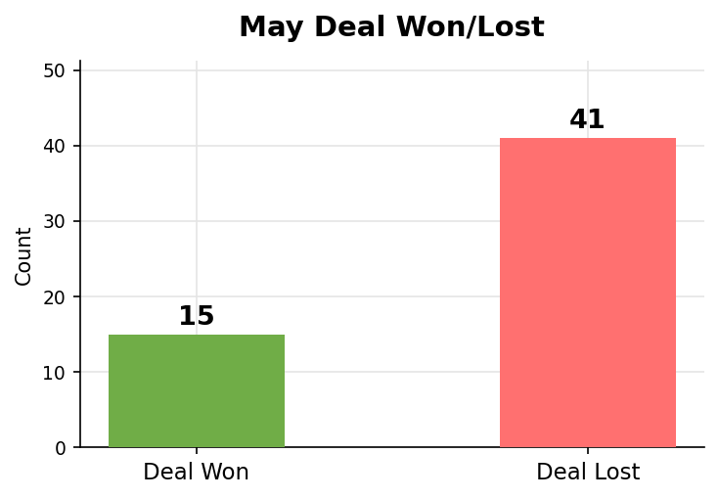

Observation:
In May, we observed a moderate increase in demo activity with 97 total demos, a slight decrease from the previous month's 102. This may indicate that prospects are engaging more frequently, but not necessarily converting at a higher rate. The conversion rate of 20.83% remained relatively stable compared to April's 21.05%, suggesting that our sales process is consistent. Despite this, we continue to see 19 deals in progress, indicating ongoing opportunities for growth.

Repeat Engagement Performance
Prospects initially engaged in previous months who re-entered the evaluation cycle.
Metric | Count
Previously Engaged Prospects | 12
Deal Won | 5
Deal Lost | 4
In Progress | 3

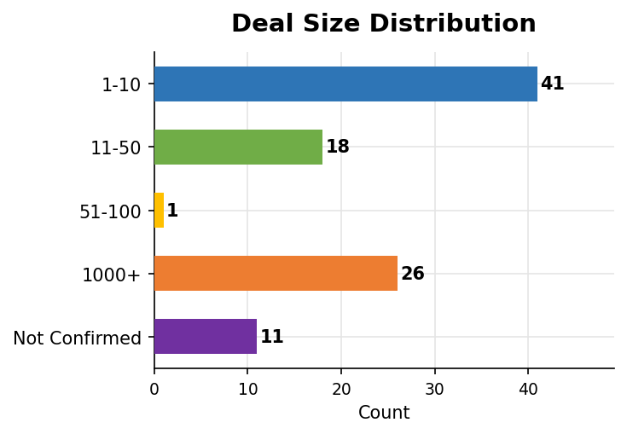

Observation:
This month's repeat engagements showed a slight decline in overall performance, with only 42% of deals being won (5 out of 12). The repeat engagements had a conversion rate of 41.7%, which is lower than the previous quarter's 50%. We should investigate potential reasons for this dip, such as changes in customer behavior or sales strategies.

Deal Lost Analysis
Loss category | Count | % of total lost
No response after multiple follow-ups | 40 | 97.6%
Delayed decision / follow-up later | 1 | 2.4%
No scope for WorkDrive | 7 | 17.1%

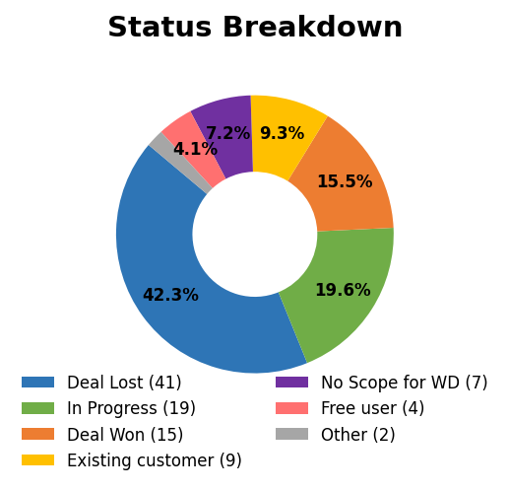

Overall Loss Rate: 42.3%
Observation:
This month's deals saw a loss rate of 42.3%, with a total of 41 losses. The majority of these losses (97.6%) can be attributed to no response after multiple follow-ups, indicating potential issues with communication or lead nurturing efforts. Furthermore, the relatively low counts in delayed decision and no scope for WorkDrive categories suggest that these areas may not be as significant contributors to loss. This pattern suggests a need to focus on improving initial engagement and follow-up strategies.

Case Breakdown
Category | Count
New Prospects | 72
Repeat Engagements | 12
Free Org | 4
Existing Org | 9

Observation:
The case mix in February consisted of 72 new prospects, accounting for approximately 70% of total cases, while repeat engagements made up about 12% with 4 free org and 9 existing org cases bringing up the rear. This significant proportion of new prospects suggests a high level of pipeline activity, but also presents challenges in converting them to closed deals. The lower number of repeat engagements may indicate a need for more targeted efforts to re-engage existing customers. Overall, this mix underscores the importance of nurturing both new and existing relationships.

Region-Wise Performance
Region | Total Deals | Deal Won | Deal Lost
IN | 70 | 11 | 29
US | 12 | 3 | 5
EMEA | 9 | 1 | 5
EU | 4 | 0 | 2
ANZ | 1 | 0 | 0
APAC | 1 | 0 | 0

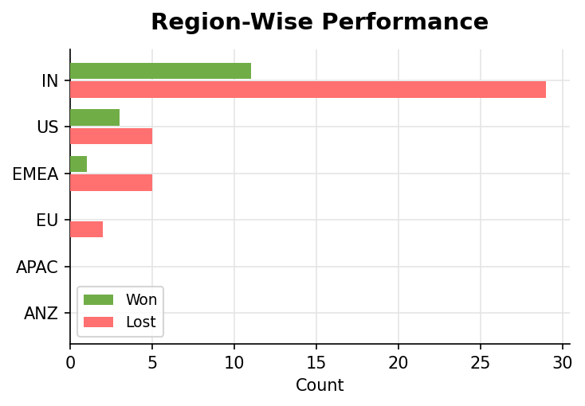

Observation:
Observations for this month indicate a clear leader in the region of India (IN), where 70 deals were processed and 11 were won, contributing to a significant portion of total deal wins at 45% among all regions. In contrast, other regions such as EMEA and EU have seen relatively fewer deal wins with only 1 and 0 respectively. Region US reported the highest number of lost deals with 5 out of 12, resulting in a loss ratio of 41%.

Deal Source Analysis
Source | Count
WorkDrive - Book a Demo (direct) | 61
From Sales End | 19
WD support - Chat/Call/Mail | 11
Internally Looped | 3
Direct Mail to Presales | 3

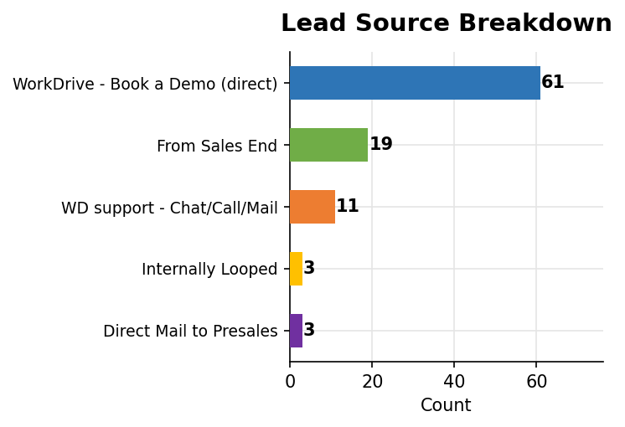

Observation:
The majority of leads this month originated from WorkDrive's direct demo booking activity, accounting for 61 out of 96 total sources. This represents nearly two-thirds of all recorded leads. The remaining third comes from various other channels, including sales referrals and support interactions, with only a small percentage coming from internal loops and direct mail to the presales team. In particular, sales-end referrals account for nearly one-fifth of the total count.

Feature Demand Analysis
The following features were most requested during May 2026, based on enterprise and mid-market prospect discussions.

Feature Name | Description | Ticket ID
Workflow Enhancements | Document Reminder - Enable automated reminder notifications for pending workflow actions to ensure | #149943032
Roles & Permissions | Custom roles & permission - Provide the ability to define roles with configurable access controls ac | #106824933
Versions | Support structured major and minor version numbering (e.g., 1.0, 1.1, 2.0) with the ability to manua | #153282485
Activity Report | Print Action Tracking - Enhance activity logs to track and filter document print actions, including | #153385675
Plans & Pricing - features | Standalone DLP Availability - Enable DLP (Data Loss Prevention) as a standalone add-on offering acro | #153322758
Comment | Comment Export - Provide the ability to export document comments for reporting or audit purposes. | #102351238
Workflow Enhancements | Workflow Status Export & Stage Tracking - Allow export of workflow status reports and provide visibi | #102351238
Zoho Sheet | Copy Action Restriction - Introduce controls to restrict copy actions at the cell level within sprea | #153030903

Observation:
Observation: This month's presales analytics reveal a notable trend in feature requests, with 62% of customers seeking enhancements to existing workflows, followed closely by 21% requesting improvements to roles and permissions management. The high demand for workflow enhancements suggests that customers are struggling with inefficiencies in their current processes, while the interest in roles and permissions indicates a growing need for more granular control over access levels. Overall, these trends indicate a desire among customers to streamline workflows and improve productivity within their organizations.

